IDENTIFICATION
Student’s name :
Health authority :
Address :

This electronic document can be used as a supplement to the FOCUS paper version received from the school at the beginning of the placement. It enables the supervisor and student to record the perceived performance and comments electronically. It must be submitted with the paper version. At any time, the most recent version of this electronic document can be downloaded from In the section FOCUS at the Web site of the l’École de réadaptation: http://www.usherbrooke.ca/readaptation/stages/documentation-de-stage/
When using this electronic form, in order to situate the performance level, it is important to have the paper version on hand. To evaluate, refer to the hierarchical listed performance criteria on the left hand pages of the paper version. Also, when evaluating each role, must support the score attributed with feedback backed by real examples.
At the mid--placement and end of placement evaluations, you will have to print this duly filled supplemental document and join it to the FOCUS and share the information with the supervisor/ student. Signatures are added once it is printed . Both the paper and printed supplement of the FOCUS must be returned signed to the Academic Coordinator of Clinical Education.
1st Supervisor’s name:
signature : Date :
2nd Supervisor’s name:
signature : Date :

Student’ signature : Date :

Role : Expert in Enabling Occupation (ASSESSMENT)
Key competencies for the occupational therapist :
- Functions effectively as a client-centred expert in occupation, occupational performance, and occupational engagement.
- Performs a complete and appropriate assessment of occupational performance.
- Applies core expertise and professional reasoning.
- Synthesize assessment findings and displays competent clinical reasoning to develop a targeted action plan.
Mid-placement  Formative feedback | End of placement  Formative feedback
  According to the expected performance level for this Placement :
  Exceeds expectations
  Is progressing according to expectations
  Is progressing with difficulty
  Is below expectations
  Competency not explored
  According to the expected performance level for this Placement :
  Exceeds expectations
  Meets expectations
  Minimally meets expectations
  Below expectations
  Competency not explored

Role : Expert in Enabling Occupation (intervention)
Key competencies for the occupational therapist:
- Apply core expertise and professional reasoning.
- Demonstrate skilled and selective use of occupation and interventions to enable occupation.
Mid-placement  Formative feedback | End of placement  Formative feedback
  According to the expected performance level for this Placement :
  Exceeds expectations
  Is progressing according to expectations
  Is progressing with difficulty
  Is below expectations
  Competency not explored
  According to the expected performance level for this Placement :
  Exceeds expectations
  Meets expectations
  Minimally meets expectations
  Below expectations
  Competency not explored

Role : Communicator
Key competencies for the occupational therapist:
- Engage in effective dialogue.
- Convey effective written and electronic documentation.
- Support diversity in communication.
Mid-placement  Formative feedback | End of placement  Formative feedback
  According to the expected performance level for this Placement :
  Exceeds expectations
  Is progressing according to expectations
  Is progressing with difficulty
  Is below expectations
  Competency not explored
  According to the expected performance level for this Placement :
  Exceeds expectations
  Meets expectations
  Minimally meets expectations
  Below expectations
  Competency not explored

Role : Collaborator
Key competencies for the occupational therapist:
- Work effectively in interprofessional and intraprofessional teams.
- Work effectively with a team to manage and resolve conflict.
Mid-placement  Formative feedback | End of placement  Formative feedback
  According to the expected performance level for this Placement :
  Exceeds expectations
  Is progressing according to expectations
  Is progressing with difficulty
  Is below expectations
  Competency not explored
  According to the expected performance level for this Placement :
  Exceeds expectations
  Meets expectations
  Minimally meets expectations
  Below expectations
  Competency not explored

Role : practice manager
Key competencies for the occupational therapist:
- Manage day-to-day professional practice and career.
- Participate in activities that contribute to the effectiveness of the organizations and systems.
- Supervise support personnel in occupational therapy.
- Support fieldwork education.
Mid-placement  Formative feedback | End of placement  Formative feedback
  According to the expected performance level for this Placement :
  Exceeds expectations
  Is progressing according to expectations
  Is progressing with difficulty
  Is below expectations
  Competency not explored
  According to the expected performance level for this Placement :
  Exceeds expectations
  Meets expectations
  Minimally meets expectations
  Below expectations
  Competency not explored

Role : change agent
Key competencies for the occupational therapist:
- Advocate for the occupational potential, performance, and engagement of clients.
- Advocate for occupational needs related to the determinants of health, well-being, and equity for clients served.
- Communicate the role and benefits of occupational therapy.
Mid-placement  Formative feedback | End of placement  Formative feedback
  According to the expected performance level for this Placement :
  Exceeds expectations
  Is progressing according to expectations
  Is progressing with difficulty
  Is below expectations
  Competency not explored
  According to the expected performance level for this Placement :
  Exceeds expectations
  Meets expectations
  Minimally meets expectations
  Below expectations
  Competency not explored

Role: scholarly practitioner
Key competencies for the occupational therapist:
- Maintain and enhance personal competence through ongoing learning.
- Critically evaluate information to support client, service, and practice decisions.
- Facilitate the learning of clients, the team, and others.
Mid-placement  Formative feedback | End of placement  Formative feedback
  According to the expected performance level for this Placement :
  Exceeds expectations
  Is progressing according to expectations
  Is progressing with difficulty
  Is below expectations
  Competency not explored
  According to the expected performance level for this Placement :
  Exceeds expectations
  Meets expectations
  Minimally meets expectations
  Below expectations
  Competency not explored

Role: professional
Key competencies for the occupational therapist:
- Demonstrate ethical practice.
- Demonstrate commitment to competent practice.
- Display awareness of diversity and the power issues involved in a professional relationship.
- Contribute to the occupational therapy profession.
Mid-placement  Formative feedback | End of placement  Formative feedback
  According to the expected performance level for this Placement :
  Exceeds expectations
  Is progressing according to expectations
  Is progressing with difficulty
  Is below expectations
  Competency not explored
  According to the expected performance level for this Placement :
  Exceeds expectations
  Meets expectations
  Minimally meets expectations
  Below expectations
  Competency not explored

FORMATIVE FEEDBACK

MID-STUDENT PLACEMENT
Strengths | Aspects to work during the placement
End of student Placement
Strengths | Aspects to work on for your next placement

Absent: # times: | Reason:
Late: # times: | Reason:

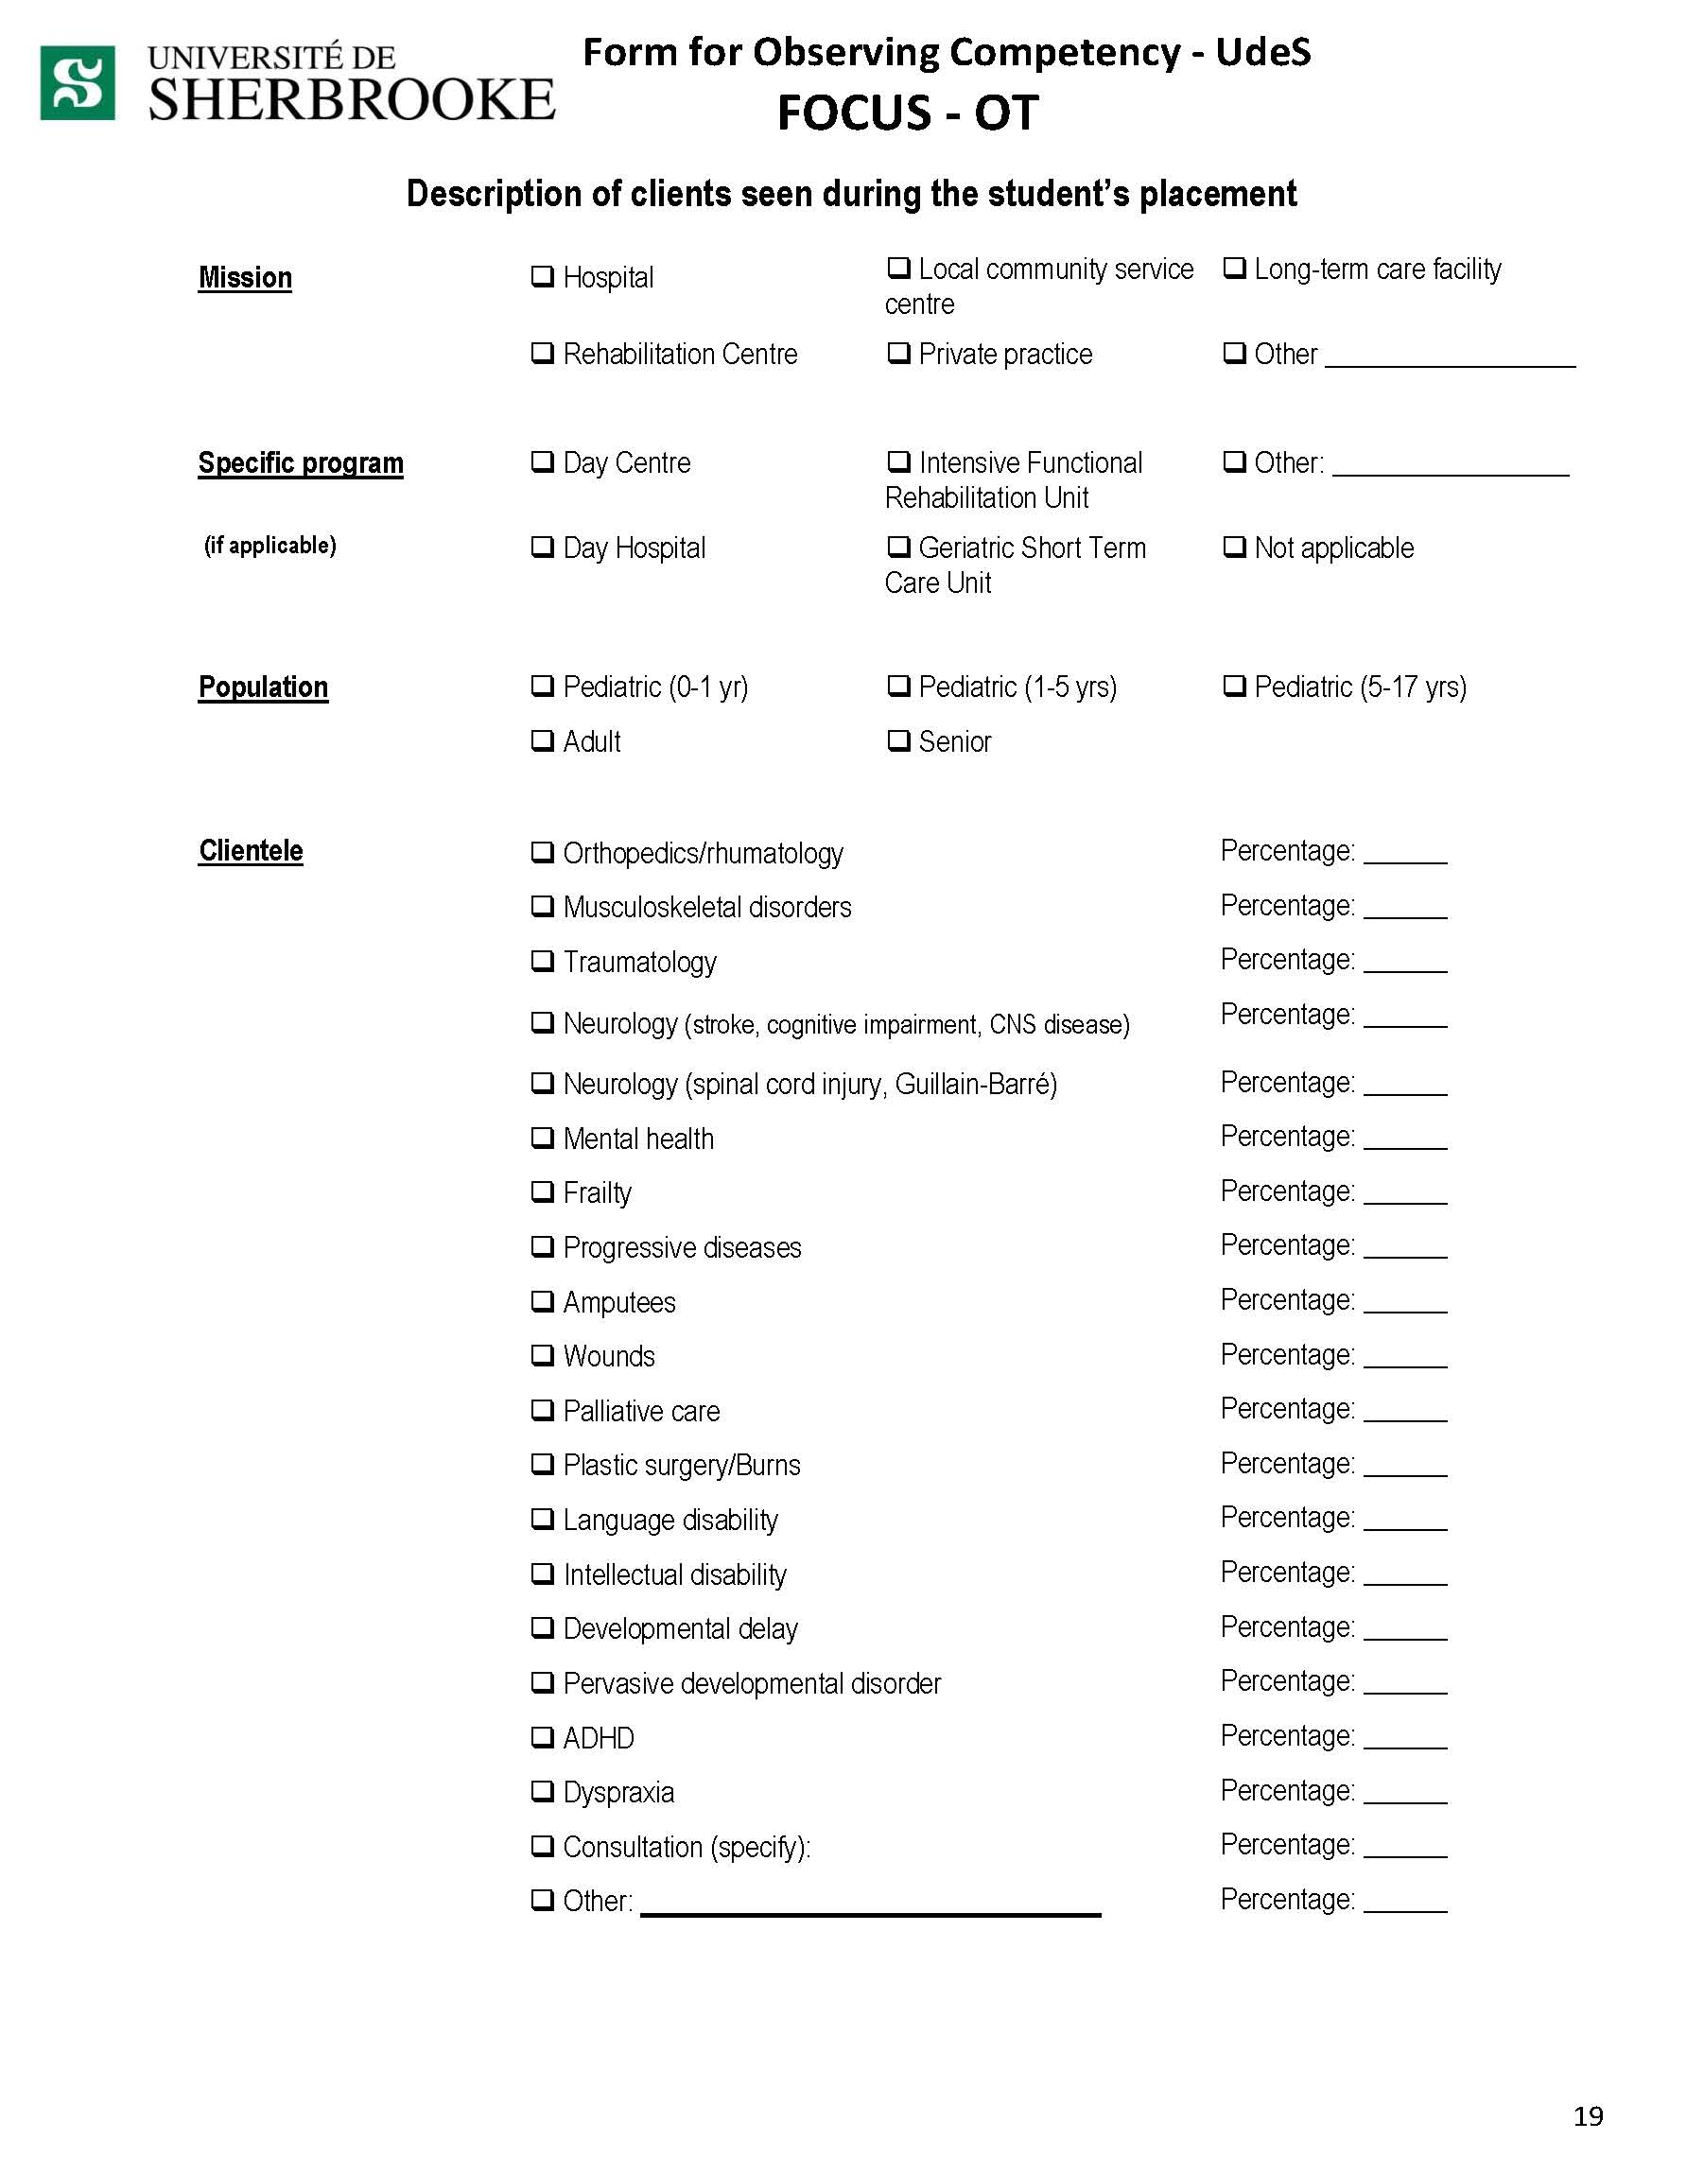

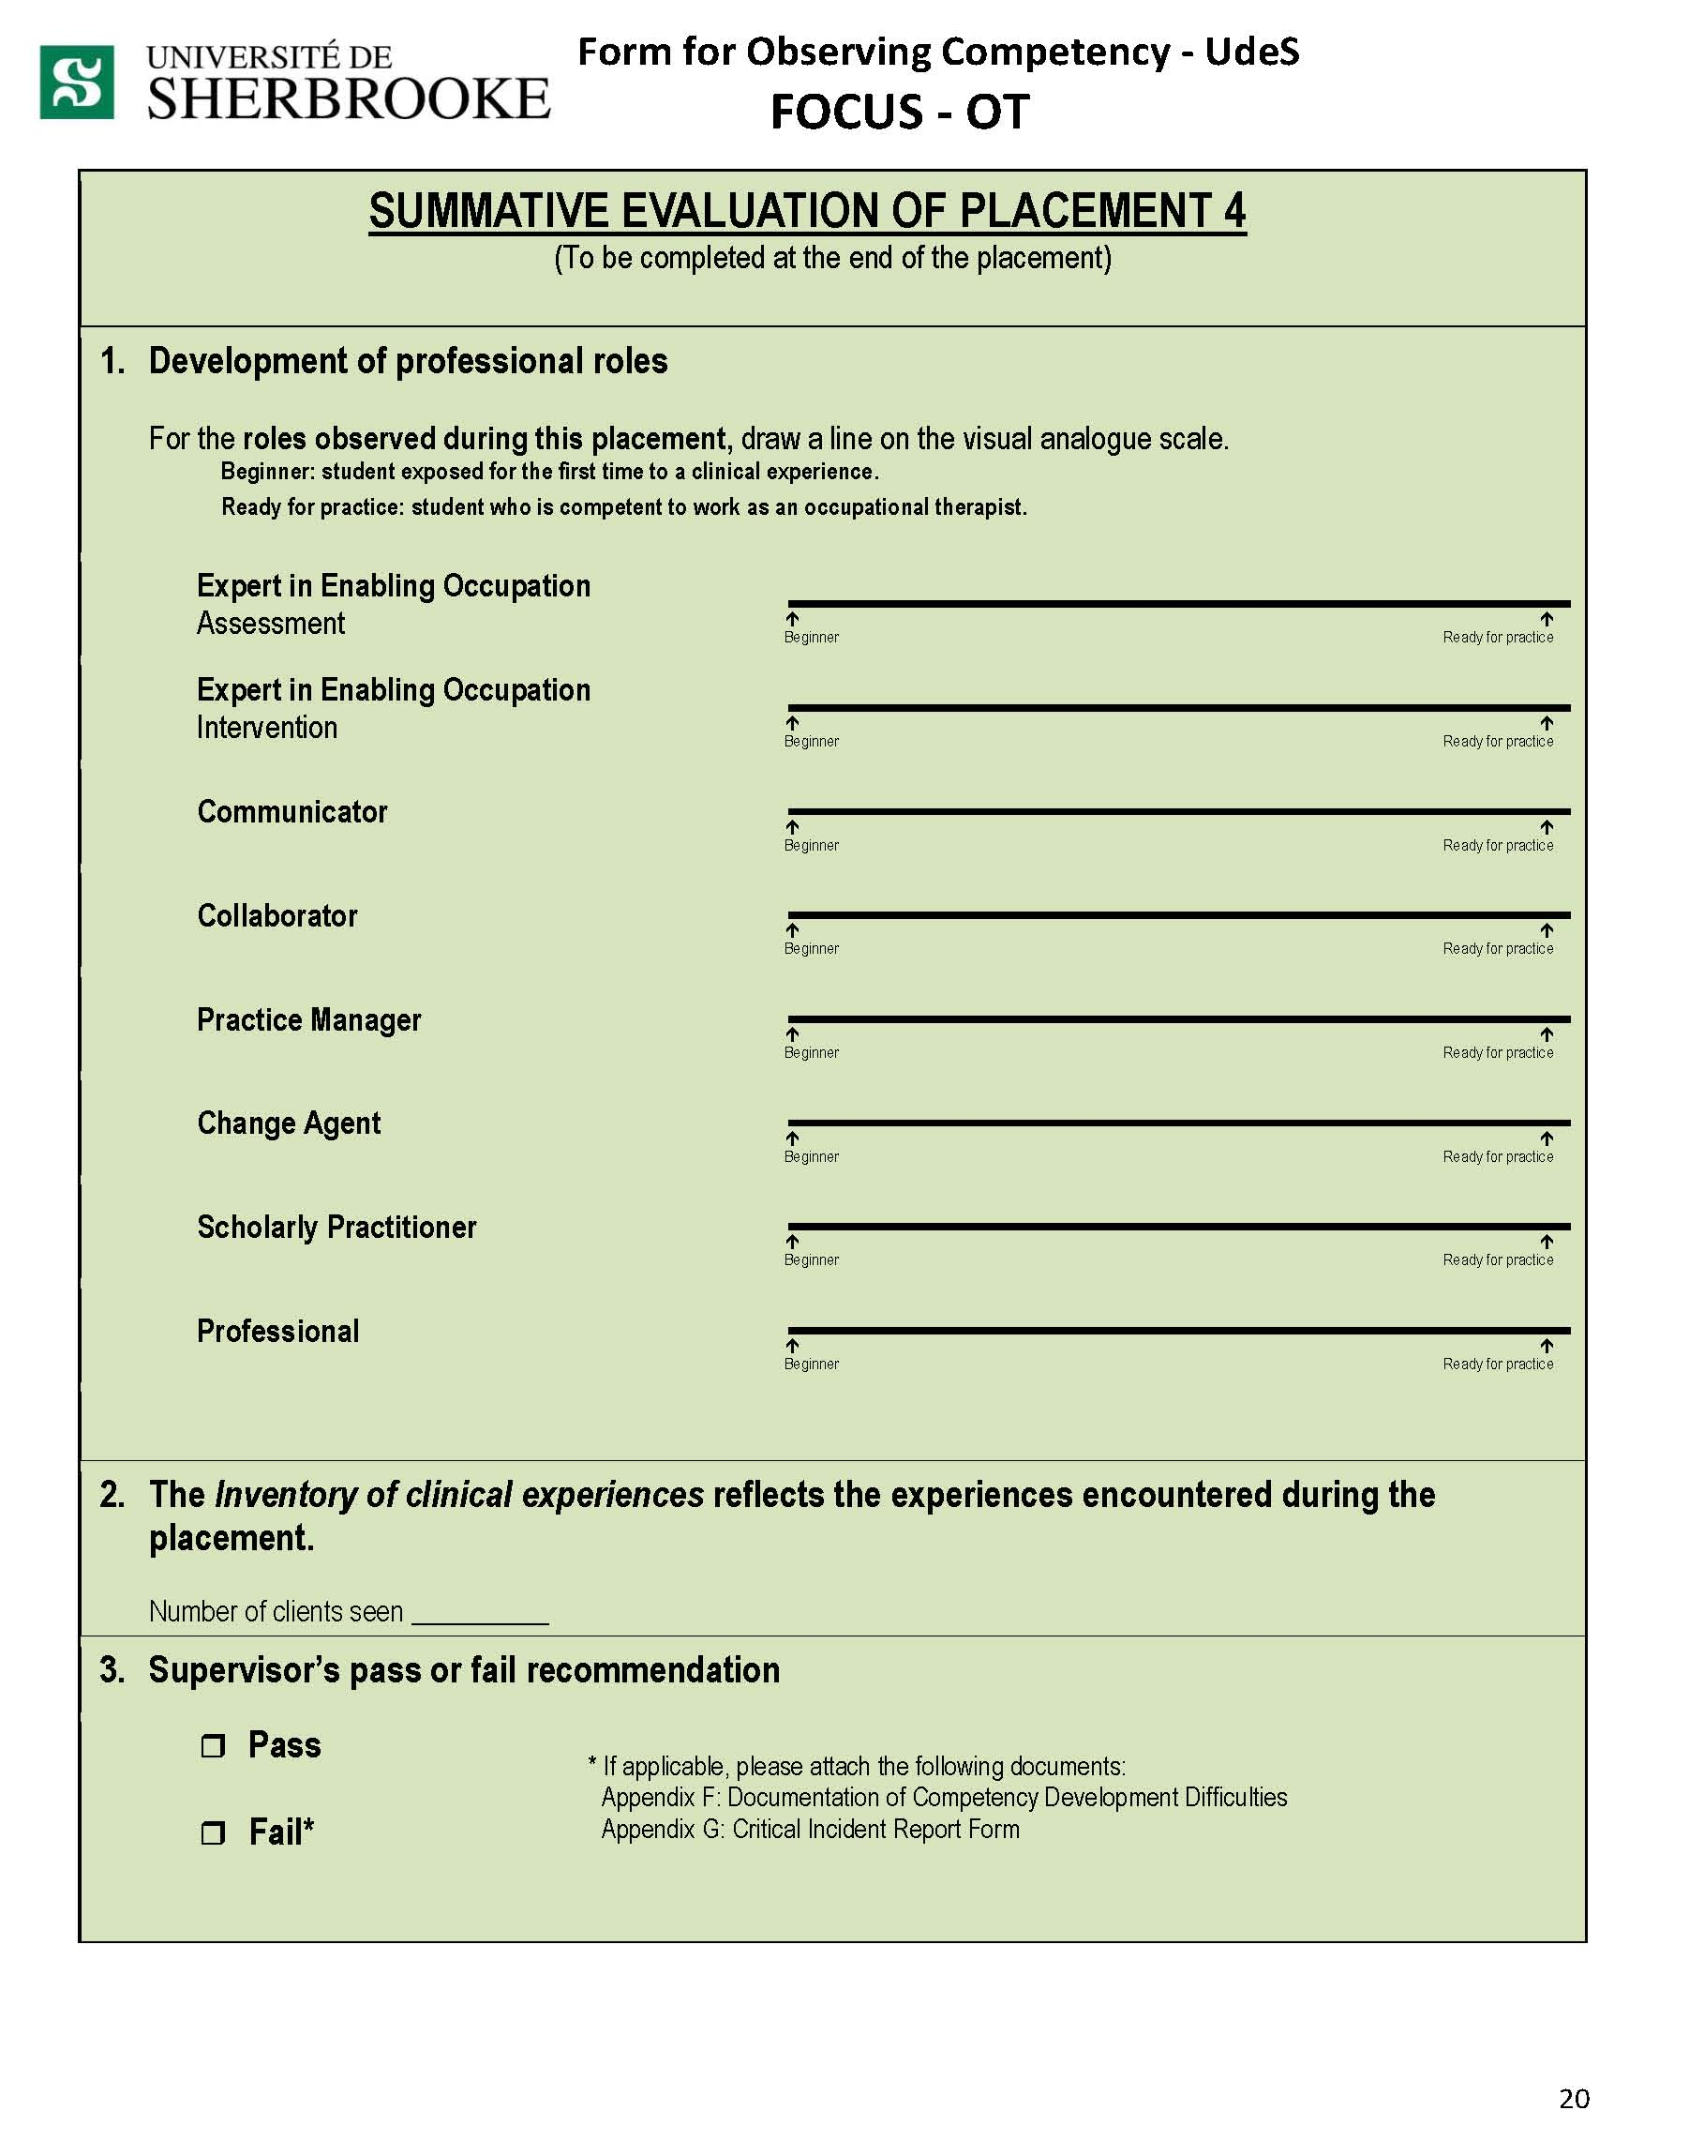

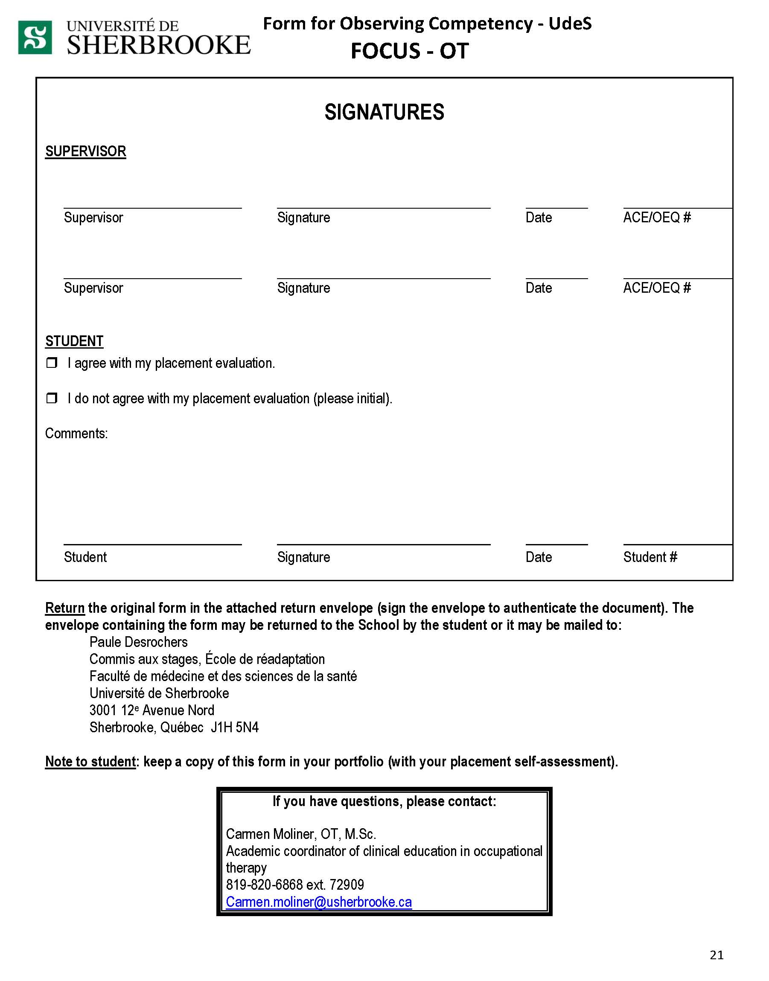

Please fill out the three last pages (21, 22, 23) of the FOCUS on the colored paper version received

