The Division of Cardiology’s Exercise Prescription Program
Participant Agreement

Benefits of Physical Activity
Regular exercise can reduce your risk of cardiovascular disease. Some other benefits include:
- Increased muscular strength
- Improved energy levels
- Reduced risk of osteoporosis

Risks of Physical Activity
The benefits of physical activity far outweigh the possible associated risks. However, the risks of starting a physical activity program include:
- Musculoskeletal injury
- Arrhythmia
- Sudden cardiac death or myocardial infarction

Program Structure
Your personal trainer will design a personalized exercise program for you to follow 2-3 times a week. Each home program will include aerobic activity, strength training, and stretching.
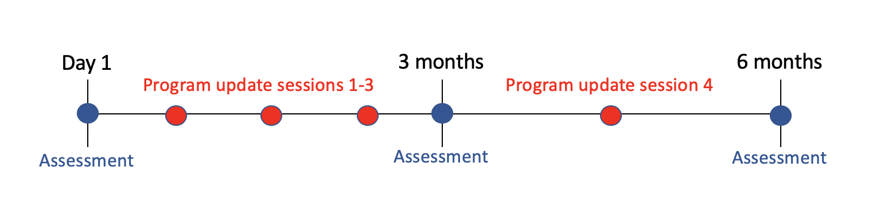
You will meet with your trainer to update your program every 3-4 weeks for the first 3 months and every 6 weeks for the last 3 months. You will be assessed at baseline, 3 months, and 6 months.

Participant Goals
- __________________________________________
- __________________________________________
- __________________________________________

Personal Training Specialist
By signing this form, I certify that I have stated the risks and benefits of the program.
Signature: ____________________________ Date: ____________________

Participant
By signing this form, I certify that I have fully disclosed all pertinent health information. I agree to commit to the program for 6 months.
Signature: ____________________________ Date: _____________________

